DIS-AFR,S-Koisan on the March-Daniell-1804

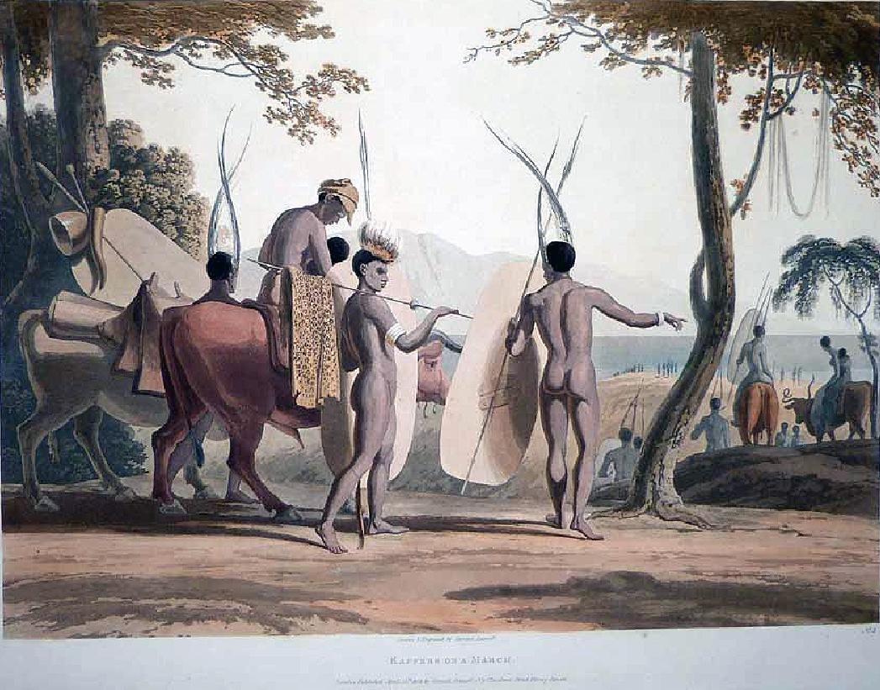

Hand-coloured aquatint. Some slight fading, otherwise in good condition. Dimensions: 350 by 472 mm (13.75 by 18.5 inches) African Scenery has been described as "the scarcest and most valuable of the large atlas folios of South African illustrations.". Daniell arrived at the Cape on 9th December 1799. He was appointed by Lieut.-General Dundas, who became his patron there, and to whom the first volume is dedicated, to act as secretary to a mission to the Booshuanas. The expedition eventually reached Lataku, at that time the limit of European exploration, and was the source for Daniell of the drawings for the present plates. Although the plate imprint states that the plates were engraved by the artist, Sutton argues forcefully that they were in fact engraved by William Daniell. "The African Scenery . is comparable in skill and execution to the Oriental Scenery. The coloured plates represent local scenery, animals singly or in groups in their natural surroundings, native types, and views of kraals. It may safely be said that never before had drawings of animals been presented so beautifully in their natural scenery . [other plates] are valuable records of early itinerant life in South Africa." Abbey Travel 321; Gay 3136; Hardie 133; Mendelssohn I, 411-12; Prideaux 245; Sutton 106-7, No. 1 (p153); Tooley 168. Bookseller Inventory #

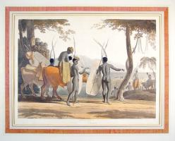

61480

**Kaffers on a March**

  45 cm x 32 cm aquatint (image area), 56 cm x 44 cm sheet size, original hand colour, London, 15 April 1804

We are pleased to offer this scarce and important original fine art aquatint by [Samuel Daniell](http://en.wikipedia.org/wiki/Samuel_Daniell) (1775-1811) from his extraordinary work *African Scenery and Animals at the Cape of Good Hope*.  The younger brother of the renowned British artist [William Daniell](http://en.wikipedia.org/wiki/William_Daniell) (1769-1837) and the nephew of landscape painter [Thomas Daniell](http://en.wikipedia.org/wiki/Thomas_Daniell) (1749-1840), Samuel Daniell's premature death has meant that he is perhaps not as well known as his relatives, but art historian Thomas Sutton in his 1954 work *The Daniells - Artists and Travellers* describes him as "the most inspired and original of the three."  Daniell visited South Africa shortly after the first British occupation and was appointed by the acting governor in 1801 to serve as secretary and draughtsman for an expedition into "the country of Booshuanas" (Botswana).  The expedition reached what was then the remotest point of Southern Africa yet visited by Europeans, and it was on that journey and the return to the Cape that Daniell recorded the images such as this that he later transformed into aquatint prints that demonstrate an unsurpassed mastery of the medium.  Here in one of the most sought-after prints of the series Daniell depicts a group of [Korana](http://www.southerncape.co.za/history/people/korana.php) people (an offshoot of the [Khoisan](http://www.southafricaholiday.org.uk/history/tnl_khoisan.htm) chiefdoms) herding their livestock in a long trek across the countryside in the [Orange River](http://en.wikipedia.org/wiki/Orange_River) region of what is now the Northern Cape.  Well preserved with the image area essentially pristine, this example has been professionally laid down on a thin board many years ago by [Herbert Evans](http://herbertevans.co.za/index.php?id=4) of Johannesburg and will make a superlative presentation if matted and framed.

Daniell noted that "Their animals consist of horned cattle, sheep, goats, and dogs. They have no kind of carriages, but, on their removal from place to place, their mats, their household furniture and utensils, are packed on oxen which, in addition, usually carry the women and children."

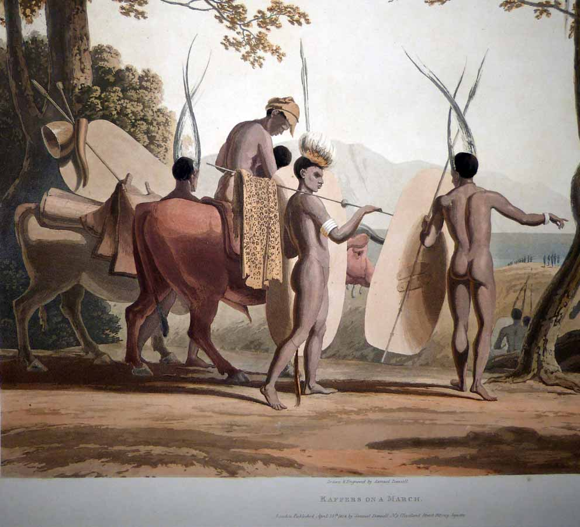

Daniell's mastery of the aquatint medium is apparent in that the term actually reflects that the method was intended to imitate the effect of a watercolour wash painting, but with the enhancement of subtle application of spirit-ground aquatint grain to provide "texture" as this greatly enlarged photo illustrates.  Note the delicate variations in the aquatint grain with multiple layers of "biting" that Daniell employs to permit the image to be created without any sharply delineated etched lines.  Daniell clearly planned for his technique to come to fruition with the final hand colour work which is of exceptional quality and possibly by Daniell himself:

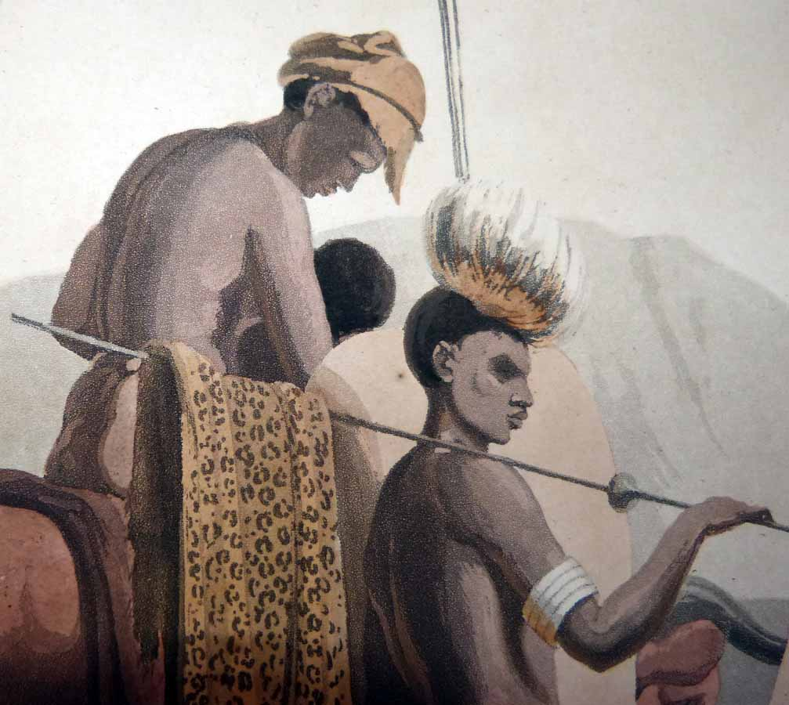

Daniell's colleague on the expedition William Somerville noted in his journal that "this party consisted of the whole family of every age together with their cattle, sheep, houses and arms."  He further noted in another encounter with the same group that "some Kora arrived bringing with them four cattle that had escaped from our herd. This was another ... example of the strict fidelity of the natives and was suitably rewarded."

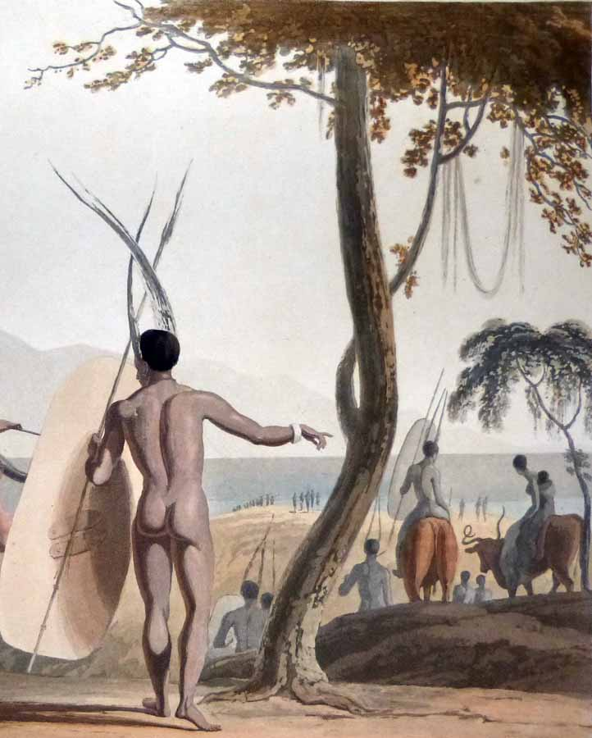

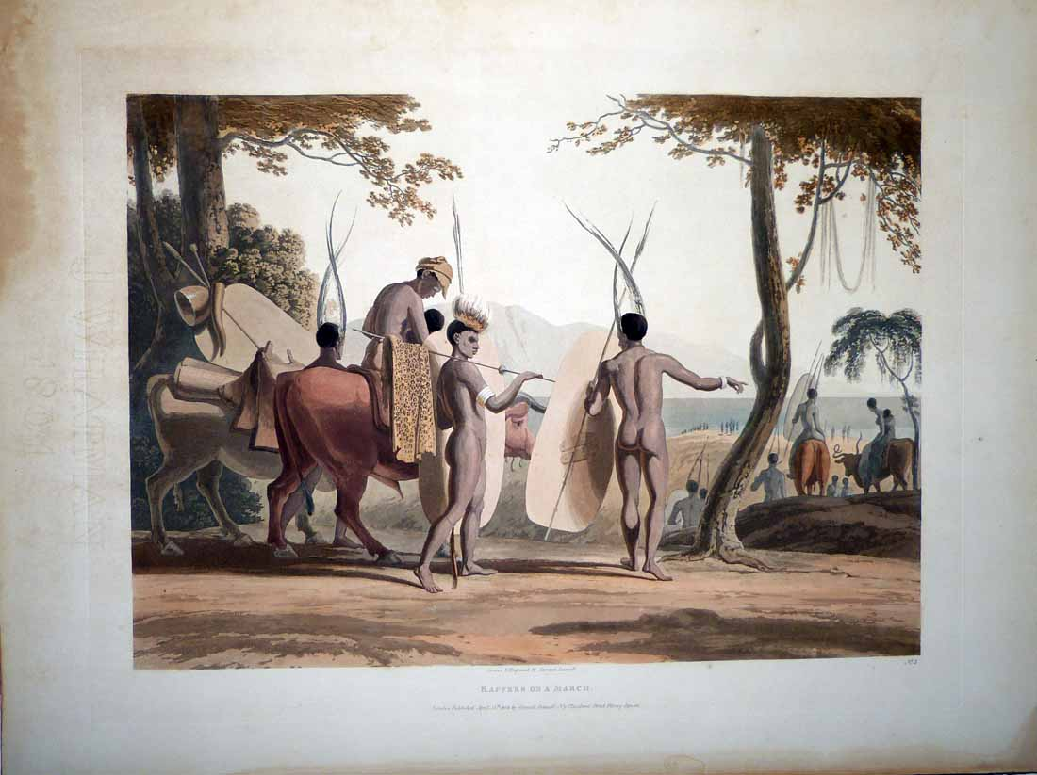

Condition - Please note carefully:   This scarce fine art aquatint is in overall excellent condition as can be ascertained from photos with the image area essentially pristine, original hand colour vivid with a rich patina, printed on fine [J. Whatman paper](http://www.whatman.com/TestamentToQuality.aspx) with watermark legible in margin.  The **print has been laid down onto a thin board long ago** and was obviously framed at one time as an outline of an old passe-partout is visible on recto in outer margin.  The print exhibits some soiling and staining to margin extremities well outside image area and if matted to the spot it was before would be entirely irrelevant.    [Inquiries](mailto:jfazli@ix.netcom.com) welcome and we encourage you to visit our other [auctions](http://cgi6.ebay.com/aw-cgi/eBayISAPI.dll?ViewListedItems&userid=regiomontanus&sort=3&since=-1) on eBay.